**SHA1 and MD5**

**Server Code:-**

import socket

import hashlib

def hash_message(message):

sha1 = hashlib.sha1(message.encode()).hexdigest()

md5_ = hashlib.md5(message.encode()).hexdigest()

return sha1, md5_

def start_server():

server_socket = socket.socket(socket.AF_INET, socket.SOCK_STREAM)

server_socket.bind(('localhost', 8085))

server_socket.listen(1)

print("Server is listening on port...")

while True:

client_socket, addr = server_socket.accept()

print(f"Connection from {addr} has been established.")

message = client_socket.recv(1024).decode()

print(f"Received message: {message}")

sha1, md5_ = hash_message(message)

response = f"SHA-1: {sha1}, MD5: {md5_}"

client_socket.send(response.encode())

client_socket.close()

start_server()

**Client code :-**

import socket

def send_message(message):

client_socket = socket.socket(socket.AF_INET, socket.SOCK_STREAM)

client_socket.connect(('localhost', 8085))

client_socket.send(message.encode())

response = client_socket.recv(1024).decode()

print(f"Response from server: {response}")

client_socket.close()

message = input("Enter a message to hash: ")

send_message(message)

OUTPUT:-

Server Output:-

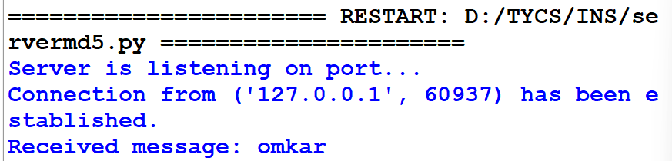

Client Output:-

